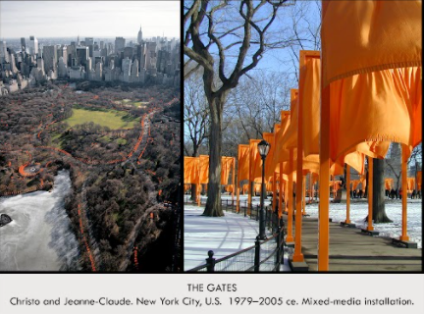

| **Form:** mixed Media Installation of 7,503 “gates” of free-hanging saffron- colored fabric panels. Framed all pathways in Central Park in New York City- originally designed by Olmsted & Vaux. Mounted in winter so that colors have big impact; trees were bare & the gates easily visible. 16’ tall gates formed a continuous river or color - - - Covered twenty-three miles of footpaths  **Function:** The work was put on hold for many years but installed a few years after 9/11. Temporary installation sixteen days - After the exhibition closed the materials were recycled  **Content:**  In February 2005, joy & beauty came to Central Park as over four million visitors enjoyed new ways of seeing & experiencing a well-known landscape. The park- showed the saffron colored corridors offered a welcome in contrast to New York City’s rigid geometrically gridded streets and avenues. When seen from the skyscrapers surrounding the park, the Gates were poetically described by Christo & Jean-Claude, as a golden river appearing & disappearing through bare branches of trees & highlighting shapes of meandering footpaths.  **Context:** Christo & Jeanne Claude first proposed the Gates in 1979. Spectators walked through the gates . The Gates illustrates their vision of transforming familiar urban park into a dramatic example of environmental art. The couple maintained their artistic independent by funding the project from sale of original drawings, collages & models. Bureaucratic regulations presented seemingly insurmountable obstacles that delayed the project for 26 years.Christo & Jeanne Claude insisted their artistic creations are designed to inspire “joy & beauty” not give deep messages. Christo is Bulgarian born, Jeanne-Claude is of French descent, born in Morocco  **Compare:** Great Portal Chartres – Todai-ji – Forbidden City  **224**  Global Contemporary |
| --- |



| **Form:**  **Function:**  **Content:**  **Context:**  **Compare:**  **225**  Global Contemporary |
| --- |

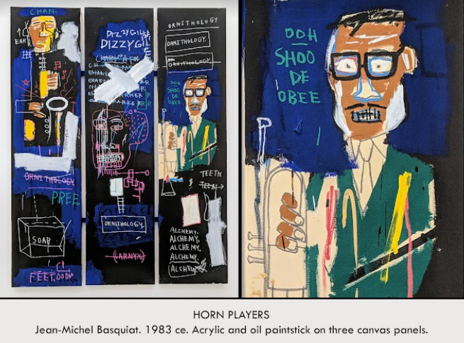

| **Form:**  **Function:**  **Content:**  **Context:**  **Compare:**  **226**  Global Contemporary |
| --- |

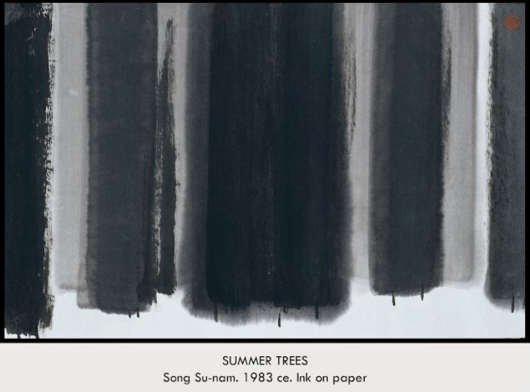

| **Form:**  **Function:**  **Content:**  **Context:**  **Compare:**  **227**  Global Contemporary |
| --- |

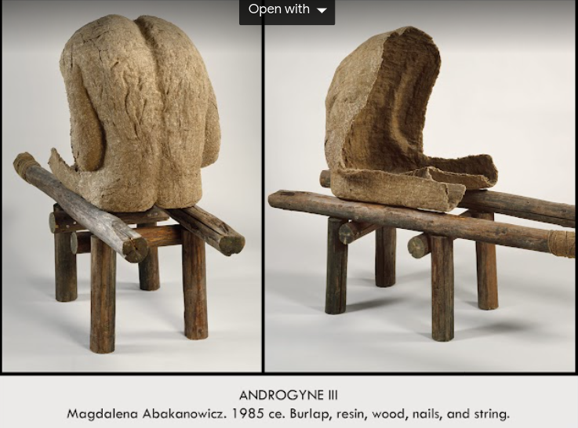

| **Form:**  **Function:**  **Content:**  **Context:**  **Compare:**  **228**  Global Contemporary |
| --- |

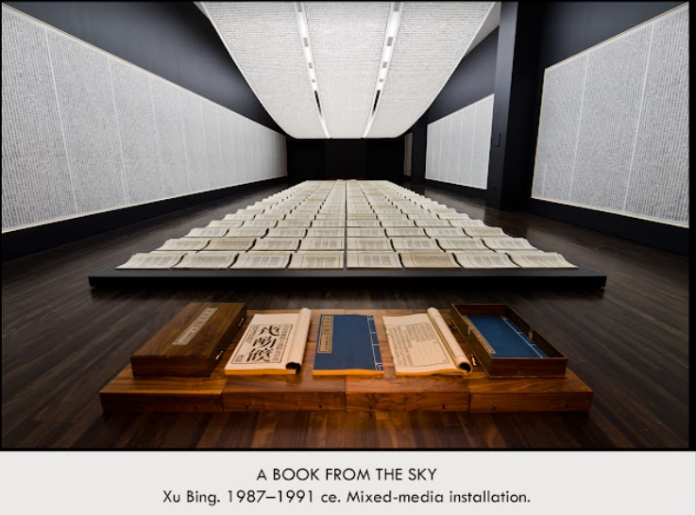

| **Form:**  **Function:**  **Content:**  **Context:**  **Compare:**  **229**  Global Contemporary |
| --- |

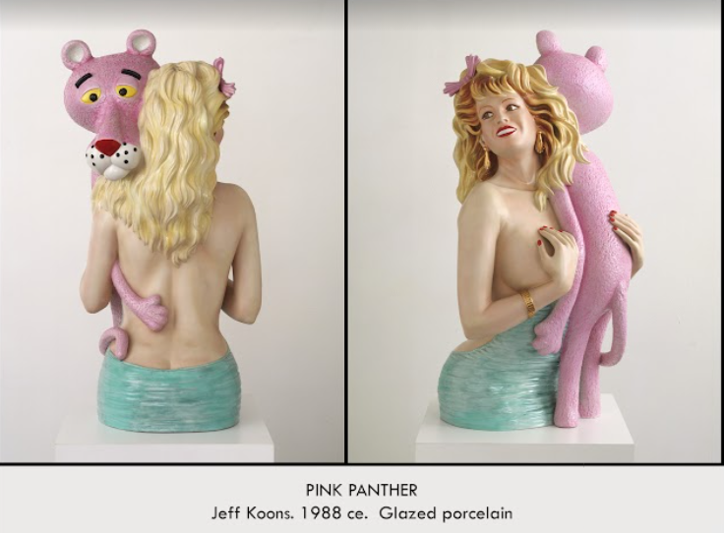

| **Form:**  **Function:**  **Content:**  **Context:**  **Compare:**  **230**  Global Contemporary |
| --- |

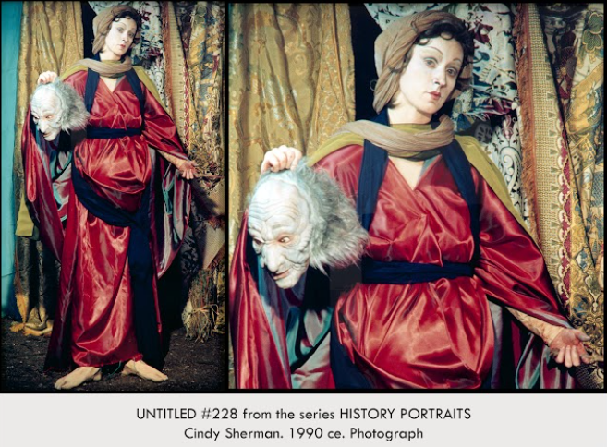

| **Form:** Stagedphotograph, classically composed, full color, “historical”  **Function:** comments on gender and identity and  **Content:**  Judith decapitating Holofernes, decorative, an overall lack of emotions, dramatic.  **Context:** part of a series.  **Compare:**  **231**  Global Contemporary |
| --- |

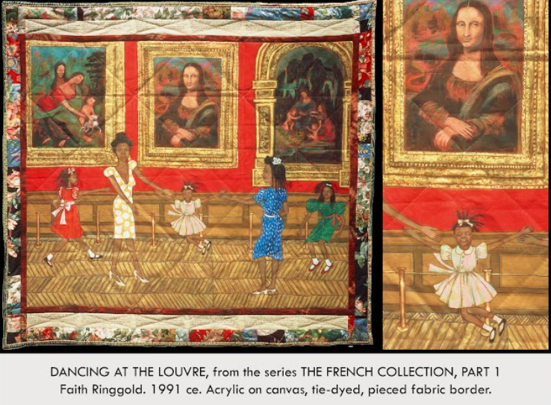

| **Form:**  **Function:**  **Content:**  **Context:**  **Compare:**  **232**  Global Contemporary |
| --- |

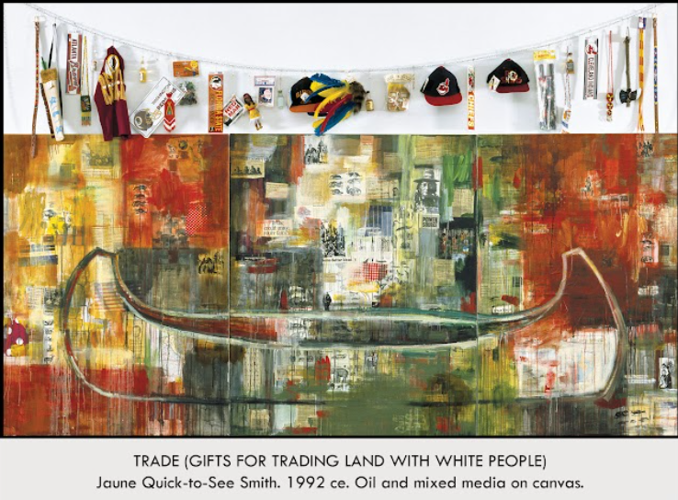

| **Form:**  **Function:**  **Content:**  **Context:**  **Compare:**  **233**  Global Contemporary |
| --- |

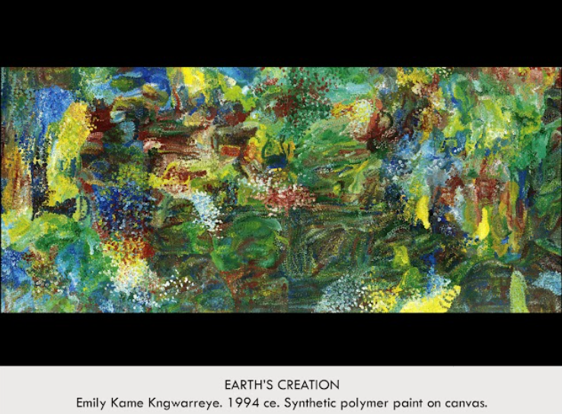

| **Form:**  **Function:**  **Content:**  **Context:**  **Compare:**  **234**  Global Contemporary |
| --- |

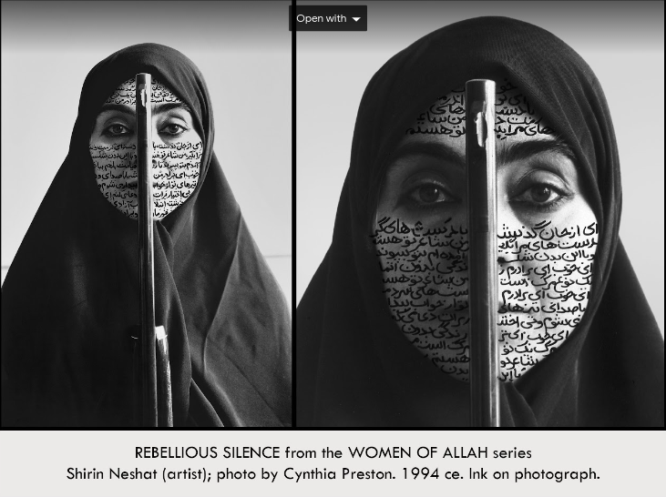

| **Form:**  **Function:** Part of a series which examines the complexity of women's identity in the midst of challenging cultural landscape in the middle east, done as a response to the oppressive situation of women in iran  **Content:**  **Context:**  **Compare:**  **235**  Global Contemporary |
| --- |

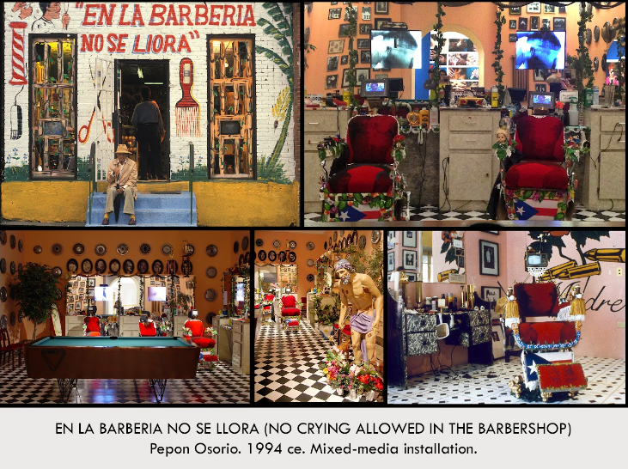

| **Form:**  **Function:** Make a statement about gender identity and wat it means to be masculine and examine that part of identriy.  **Content:**  **Context:**  **Compare:**  **236**  Global Contemporary |
| --- |

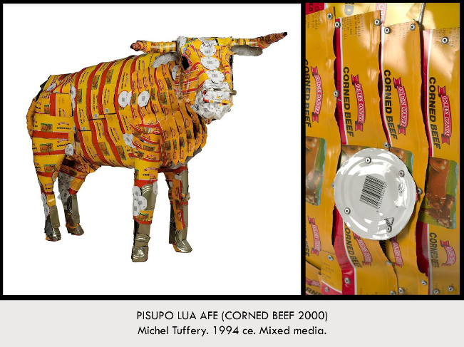

| **Form:**  **Function:**  **Content:**  **Context:**  **Compare:**  **237**  Global Contemporary |
| --- |

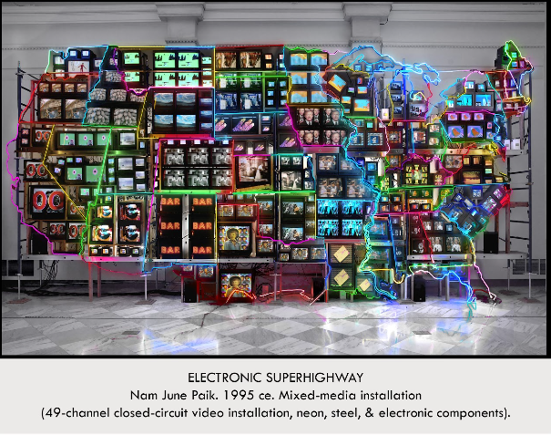

| **Form:**  **Function:**  **Content:**  **Context:**  **Compare:**  **238**  Global Contemporary |
| --- |

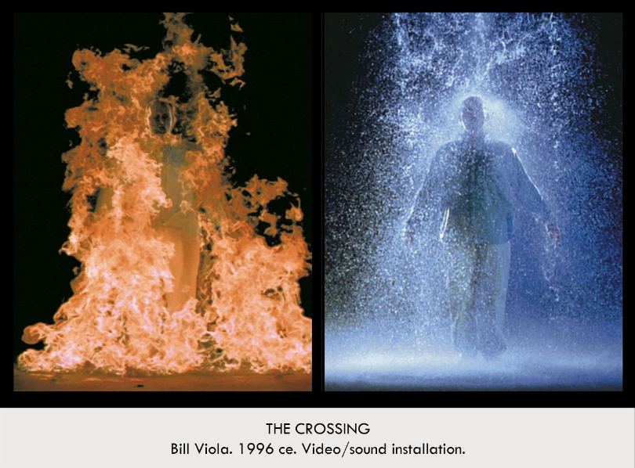

| **Form:**  **Function:**  **Content:**  **Context:**  **Compare:**  **239**  Global Contemporary |
| --- |

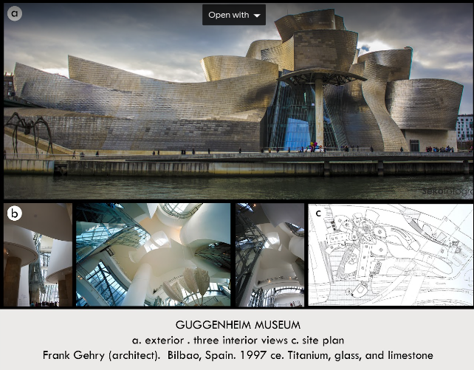

| **Form:**  **Function:**  **Content:**  **Context:**  **Compare:**  **240**  Global Contemporary |
| --- |

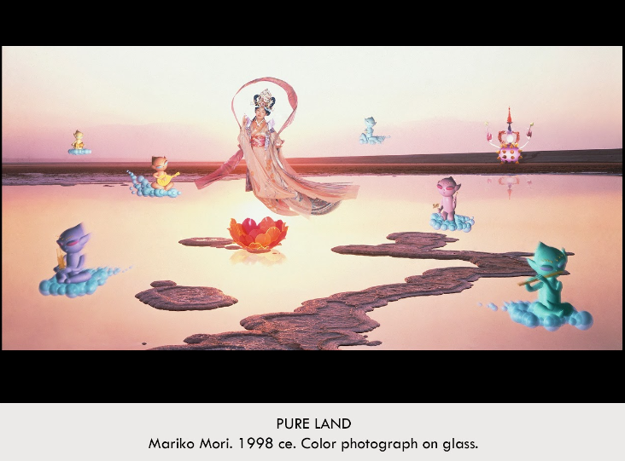

| **Form:** color photography set within glass. A screenshot of a 3D video 10 by 20 ft by ¾ inches  **Function:** a captured moment of Mori’s 3D video installation of nirvana, 1997. Pure land captures the experience of the preformed video, gives the viewer a more meditative relationship with the work. Gives tranquility and transcendence through this immersive experience. Acknowledges and challenges Japan’s uptight social norms.  **Content:**  futuristic art. This show the stage and enlightenment of earth and rebirth, the setting is the dead sea, salt symbol of purity and the lotus flower symbolizes purity and reincarnation, spaceship= Tibetan stuba. Help Jewel=buddha’s universal mind. Sunset landscape. She is portrayed as the goddess Kichijoji decorated in traditional japanese pink robes floats serenely over the golden water. Below  **Context:** artist found inspiration from anime and other popular things from asian culture. Part of Nirvana that shoes the 4 stages and elements.  **Compare:** pop art references of anime, travelers among mountains and streams  **241**  Global Contemporary |
| --- |

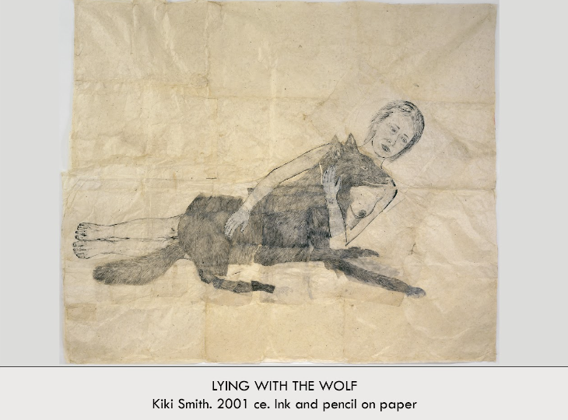

| **Form:**  **Function:**  **Content:**  **Context:**  **Compare:**  **242**  Global Contemporary |
| --- |

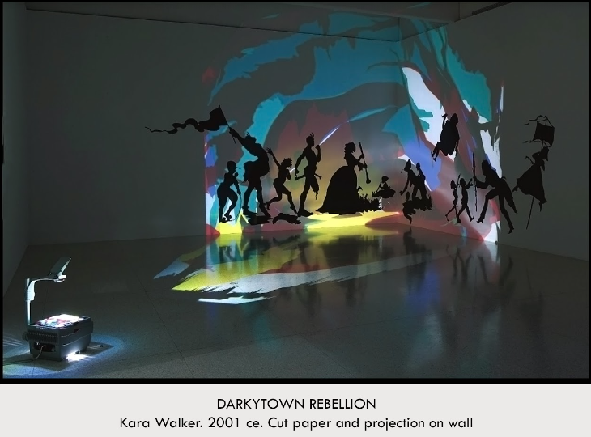

| **Form:** black paper cut out pasted on the wall with a light projection behind it. Instillation art, cutouts with colored light Technique : Draws images with a greasy white pencil or soft pastel crayon on large prices of black paper – cuts paper with a knife.  **Function**: artist art explored african american racial identity  **Content**: Images adhered to gallery wall with wax . Traditional silhouette forms . Overhead projectors throw colored light onto the walls – ceilings – floor. Cast shadows of the viewers body that mingle with the black paper images. Viewer interacts with the work – walking around it – engaging in elements of it – viewer is part of the history of the piece  **Context**: California born – New York based African American artist . Exploration of African Americans in the antebellum South – teenager holds a flags that resembles a colonial ship sail – one man has his leg cut off – a woman is caring for newborns . Kara Walker is an American contemporary painter, silhouettes, print-maker, installation artist, and film-maker who explores race, gender, sexuality, violence, and identity in her work. She is best known for her room-size tableaux of black cut-paper silhouettes. Best known for exploring the raw intersection of race, gender, and sexuality through her iconic, silhouetted figures. Walker unleashes the traditionally proper Victorian medium of the silhouette directly onto the walls of the gallery, creating a theatrical space in which her unruly cut-paper characters fornicate and inflict violence on one another.  **Compare**: history painting. Wall surfaces Lascaux Caves - Tomb of Triclinium – Sistine Chapel Ceiling  **243**  Global Contemporary |
| --- |

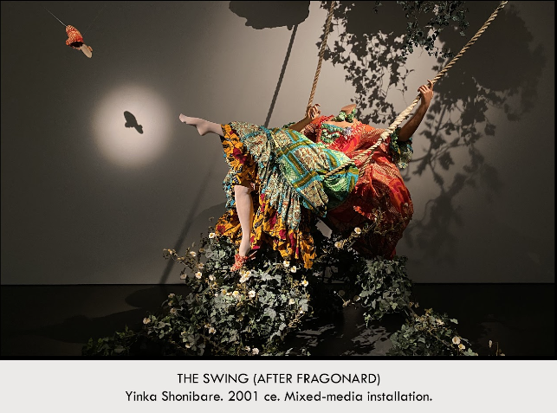

| **Form:** mixed media instillation, life sized mannequin, that is attired in a dress made of African print fabric, The intillatin also includes a swing seat, ropes, oak twig and artificial foliage. at the Tate London  **Function:** To recreate  **Content:**  he changed the original and shows a twist of the original painting. Inspired by Fragonard’s The Swing. Life size headless mannequin. Dress made of Dutch wax fabric – sold in Africa – global trade & post-colonial life in Africa. Flowering vines cast to the floor. Headless figure – guillotined by the French Revolution. He reconfigures iconic imagery from the Western art-historical canon with a playful & ironic touch.  **Context:** artist was born in london, work explored interatic between african culture ans european cultures. Artist is British born of Nigerian descent – lives and works in London . Two men in Fragonard painting are not included – audience takes the place of the men. Erotic voyeurism. Yinka Shonibare is a British-Nigerian artist living in the United Kingdom. His work explores cultural identity, colonialism & post-colonialism within the current context of globalization. Growing up in the U.K. & Nigeria, Yinka Shonibare investigates political & social histories related to post-colonialism & globalization. Working in sculpture, film, photography & painting, Shonibare is known for his tableaux of characters dressed in spectacular period costumes made from batik (Indonesian fabric - produced in the Netherlands -assimilated in West Africa).  **Compare:** The swing by Fragonard. **Depicting Motion .** Muybridge – Alexander Mosaic – Rodin Burghers of Calais  **244**  Global Contemporary |
| --- |

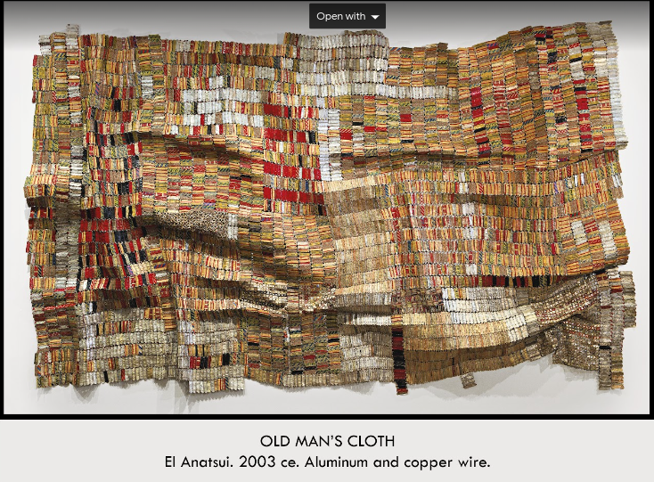

| **Form:** Aluminum and copper wire  **Function:**  **Content:**  One thousand drink tops joined by wire to form a cloth like hanging . Bottle caps from a distillery in Nigeria . Artist uses power tools such as chain saws and welding torches . Converts found materials into a new type of media that lies somewhere between painting and sculptures . Recycling of found objects  **Context:** Artist born in Ghana spent much of his career in Nigeria. Colorful, textured wall hangings, relates to West African textiles – the fold color reflects traditional cloth colors of Chana and references royalty. Combines aesthetic traditions of artists home country of Chana – his adapted country of Nigeria and the global art movement of abstract art. El Anatsui (born 1944) is a Ghanaian sculptor active for much of his career in Nigeria . He has drawn particular international attention for his iconic “bottle-top” " installations". Distinctive large-scale assemblages of thousands of pieces of aluminum from alcohol recycling stations . Sewn together with copper wire, transformed into metallic cloth-like wall sculptures in a way that can "draw connections between consumption, waste, and the environment  **Compare: Cloth** All T’oqapu Tunic - Hiapo - Funeral banner  **245**  Global Contemporary |
| --- |

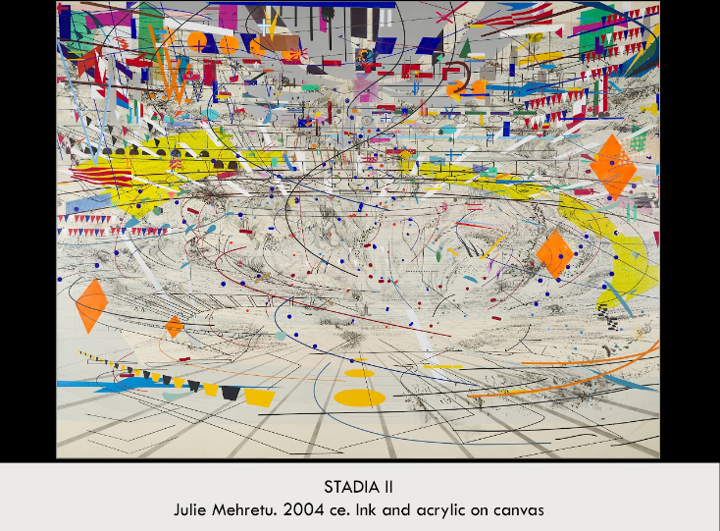

| **Form:**  **Function:**  **Content:**  **Context:**  **Compare:**  **246**  Global Contemporary |
| --- |

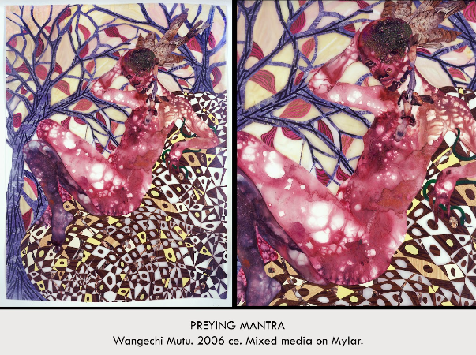

| **Form:**  **Function:**  **Content:**  **Context:**  **Compare:**  **247**  Global Contemporary |
| --- |

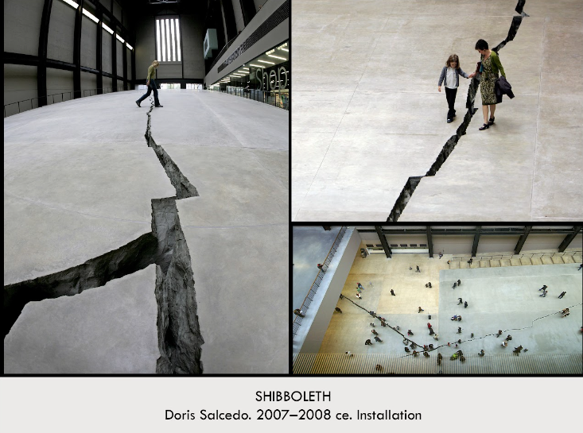

| **Form:** a 548 ft crack in the concrete floor. Shibboleth- and custom or tradition which distinguishes between one group or people an another.  **Function:** to change perspective of how people viewed immigrants. “ we should all see people from the victims perspective”  **Content:**  You walk on one side or the other. Crack is rigid and it is varied, she designed the crack to show a split between people. Visual form of the distance between us as people. An installation that features a large crack that begins as a hairline & then widens to 2’ in depth. Meant to be a “disruption” A visual metaphor to convey an abstract message. Floor of museum was opened & a cast of Columbian rock faces was inserted. The crack emphasizes the gap in relationship; a reminder of the disruption is paces References racism & colonialism; keeping people isolated - a way of separating them. Installation now sealed but exists as a scar; commemorates life of the under classes. It is the experience of a Third World person coming into the heart of Europe"  **Context:** created by a colombian artist. 7 month long exhibit and it was covered/filled ater this time. Represents racial segregation, she wants you to figure it out. Shibboleth is meant to exclude people from joining a group. A Shibboleth was originally a test phrase used to identify members of out-groups. Ethnocentrism & Shibboleths: Members of all societies use their own cultural perspectives to judge others . "represents borders, the experience of immigrants, and of segregation, the experience of racial hatred. Colombian sculptor Doris Salcedo (born 1958) Her work is influenced by her experiences of life in Colombia, and is generally composed of commonplace items. Salcedo’s work gives form to pain, trauma, & loss, while creating space for individual & collective mourning. Themes from her own history. - Members of her family disappeared in politically troubled Colombia. Deals with fact that death of a loved one can be mourned, but their disappearance leaves an unbearable emptiness.  **Compare:** Narcissist garden ( conceptual pieces and interactive)  **248**  Global Contemporary |
| --- |

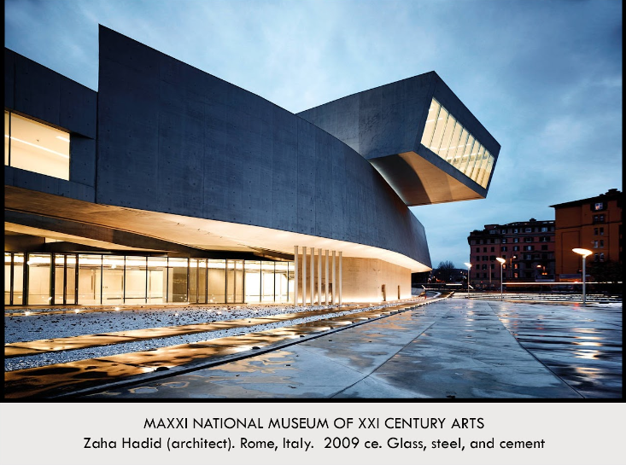

| **Form:**  **Function:**  **Content:**  **Context:**  **Compare:**  **249**  Global Contemporary |
| --- |

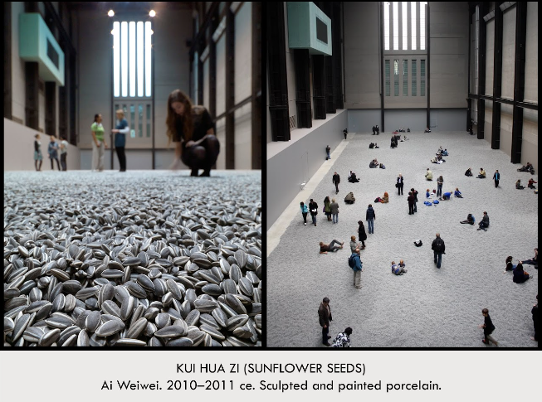

| **Form:**  **Function:**  **Content:**  **Context:**  **Compare:**  **250**  Global Contemporary |
| --- |